Dc motor rotatory encoder photoelectric speed sensor

breadboard

*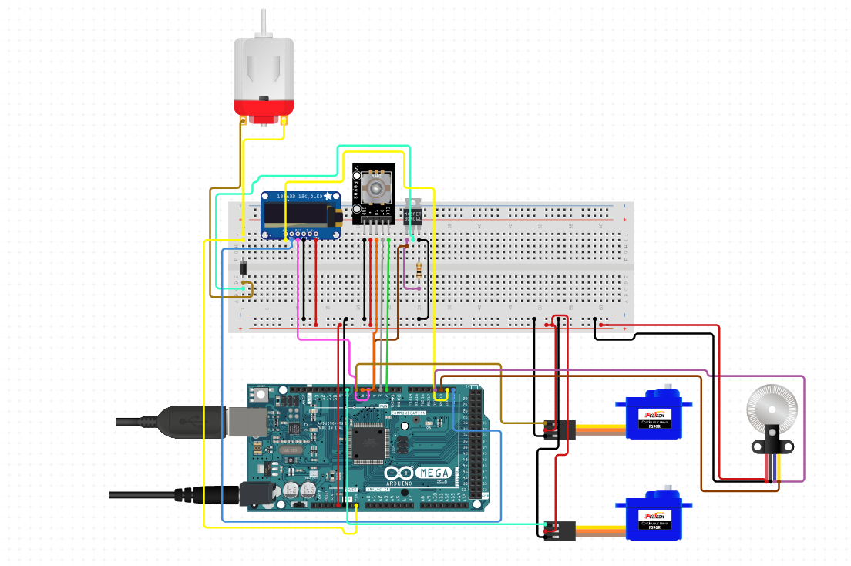*

OLED display Arduino mega AT2560

Servo motors